Lab 10: Computer Networks: Vedanth Mapakshi: 20374094

1. Creating a group

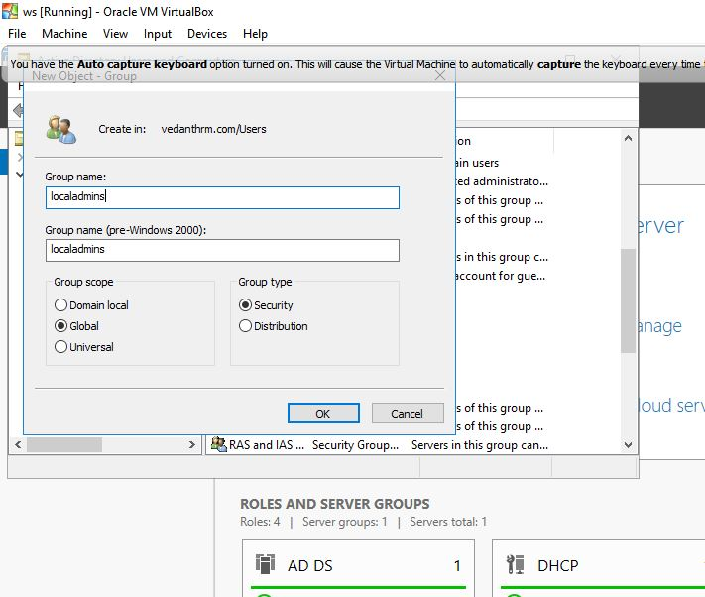

1. Creating a User

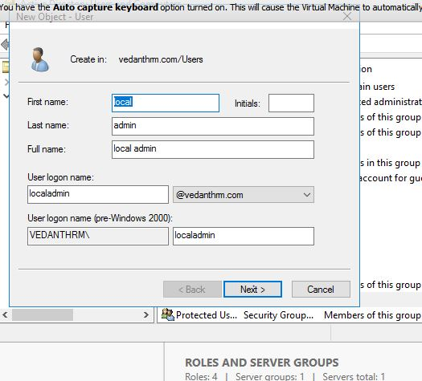

1. Adding the user to the group

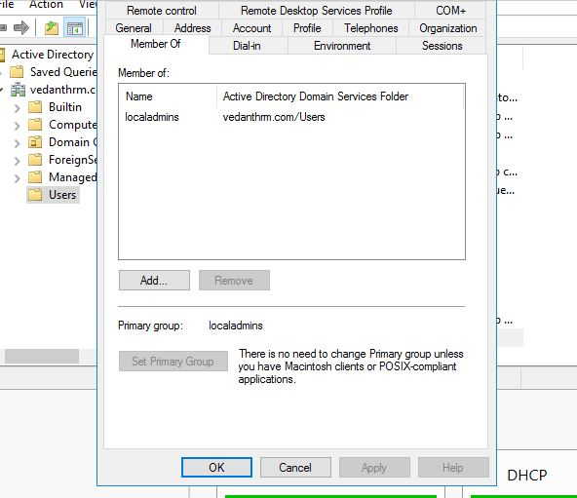

1. Creating a new group policy object

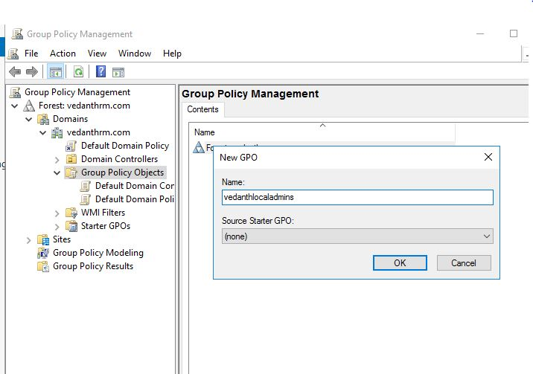

1. Making the created group a member of administrators

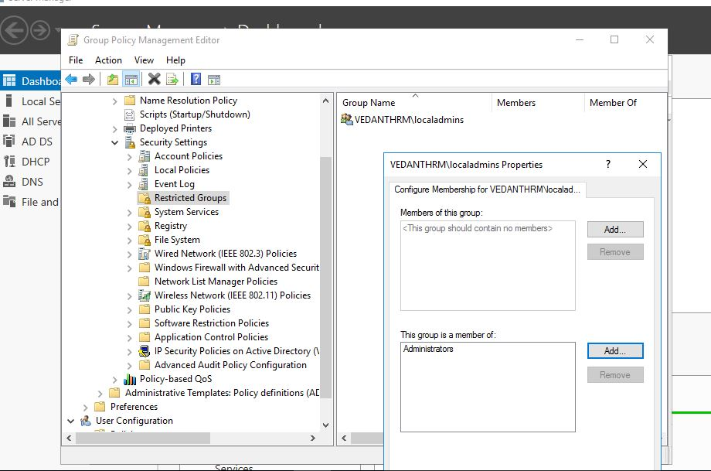

1. Linking the group policy object to the domain

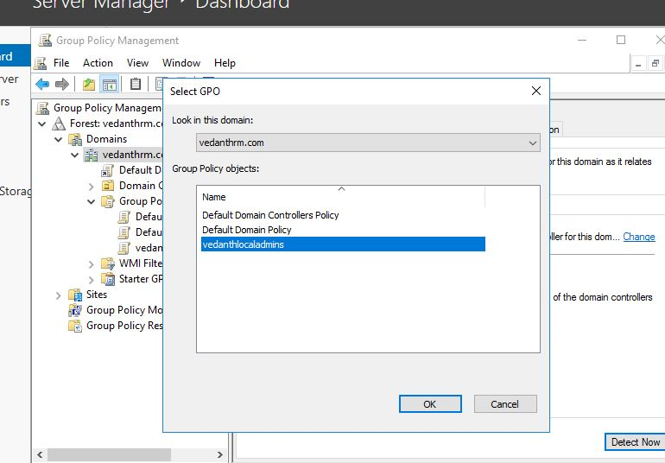

1. User Directory( Sorry sir forgot to take snap of it before kindly excuse )

